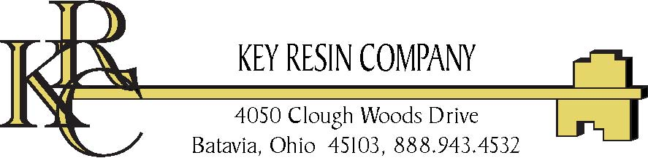

Installation Instructions

Key Epocon Chip Decorative Chip MVT Moisture Vapor Retarding System

I. GENERAL INFORMATION
KEY EPOCON Chip is designed as a decorative concrete slab surface treatment when moisture vapor transmission exceeds 3 pounds of moisture as tested with the calcium chloride test procedure (ASTM F-1869), or for use when concrete slabs test higher than 80% as tested with the relative humidity probe test (ASTM F-2170).

II. SURFACE PREPARATION
Surface Preparation is the most critical portion of any successful resinous flooring system application. All substrates must be properly prepared to a minimum surface profile of ICRI CSP-3 to a maximum CSP-6 (www.icri.org) as outlined in KEY RESIN COMPANY'S TECHNICAL BULLETIN #1. Specific attention should be paid to the following:
A. Concrete Placement
B. Curing and Finishing Techniques of the concrete substrate
C. Age of Concrete
D. Previous Contamination of the substrate
E. Present Condition of the Substrate
Also, the temperature and humidity conditions of the area to receive the flooring system should be checked. An optimum room temperature of 75ºF with a minimum slab temperature of 60ºF is required for proper cure of the resin flooring system.

III. MATERIAL QUANTITIES
Guideline System Requirements for 1000 ft²
Key Epocon Chip Decorative Moisture Vapor Control System Qty./ 1000 ft² Coverage Rate
1. Key Epocoat Primer/Scratch Coat—add 10% water 6 gallons 160 ft² /gallon
2. Key Epocoat Body Coat—add 5% water (optional) 15 gallons 65 ft² /gallon
3. Key Broadcast Chips 3-10 lbs. .01lbs. /sq.ft.
4. Key EpoGlaze MVT Tolerant UV Stable Glaze 6 gallons 160 ft² /gallon
5. Key EpoGlaze MVT Tolerant UV Stable Glaze 6 gallons 160 ft² /gallon

Note: Add 10% potable water to Key Epocoat for primer application only, add 5% potable water to Key Epocoat for bodycoat application.

IV. INSTALLATION
Note: Route cracks larger than 1/32” and fill with Epocoat during the scratch coat application. If using Key #580 Flexible Epoxy Membrane for overlaying cracks or sawcuts, the Key #580 must be applied over the finished Key Epocon SL system (i.e., over the sand broadcast, after sweeping and vacuuming all loose or poorly adhered sand, or over sand-filled Key Epocon SL with a smooth finish). If applying Key #580 over sand broadcast finish, factor additional 20% material to achieve minimum 32 mils over the sand texture.

1. Mixing Epocoat
a. Do not alter mixing ratios in any way. Part I and Part II are supplied in the correct mixing ratios. Always mix a complete unit in the proportions supplied.
b. Mix material by adding part I to part II for approximately 3-4 minutes to form a homogenous consistency using a slow speed drill and “Jiffy” blade. Do not entrap excessive air. Scrape all sides and bottom of container to ensure thorough mixing.
c. For primer/scratch coat material add 10% water to lower viscosity (16 oz per 1.25 gallons Epocoat).
2. Application
- Primer/scratch coat: Apply with a squeegee and short nap roller at a coverage rate of 160 ft² /gallon. After squeegee application, back roll with the short nap roller to achieve a uniform coverage. Allow to cure hard enough for foot traffic, about 3-4 hours at 75 degrees F.
- Bodycoat: Mix as outlined in step 1, it is optional to add no more than 5% water (8 oz per 1.25 gallons Epocoat). If using optional pigment pack (subject to availability), add 2 quarts per 5 gallons of Epocoat or 16ounces of pigment per 1.25 gallon kit and mix thoroughly. Apply mixed material using a 1/8 inch V-notched trowel/rake or 1/8 inch V-notched rubber squeegee. Immediately backroll with a looped roller. A 1.25 gallon unit will cover 80 sq. ft. @ 1/32”.
- Broadcast surface with Vinyl Chips to desired aesthetic consistency. Broadcasting procedure should begin within 5-10 minutes after spreading resin to ensure adequate absorption. Sweep, scrape and vacuum excess or loose Chips after hardening, allow for 16-24 hours of cure time, depending on temperature.

- Top Coating, Overlays, Floor Coverings
- Mixing EpoGlaze
  - Do not alter mixing ratios in any way. Part I and Part II are supplied in the correct mixing ratios. Always mix a complete unit in the proportions supplied.
  - Mix material for approximately 3-4 minutes to form a homogenous consistency using a slow speed drill and “Jiffy” blade. Do not entrap excessive air. Scrape all sides and bottom of container to ensure thorough mixing.
  - For an orange peel consistency do not add any water to the material for a thinner viscosity to allow the coat to lay down add 5% water. (8 oz per 1.25 gallons EpoGlaze).
2. Application
- To apply EpoGlaze pour out mixed material in a ribbon on the floor and squeegee approximately 10 mils thick and backroll with a 3/8 inch nap roller. Place product within 10 minutes to achieve a uniform texture in top coat.

V. WARRANTY
Key Resin Company offers warranties for systems installed by approved installers. Contact Key Resin Company for details.

